Ujala Cygnus was established in November 2019 as a merger between Ujala Healthcare and Cygnus Medicare. Ujala Cygnus Healthcare Services operations span Northern India, with 18 multi-super specialty NABH accredited hospitals, making it the largest NABH accredited super-specialty hospital chain of the region. A team of over 500 highly qualified doctors, including some of the finest names in the field of healthcare, have made these centers of excellence possible.

Grihasoft is privately held ITES KPO Company located in Bengaluru. Grihasoft is premier data quality service provider in healthcare and engineering verticals providing niche master data management of materials, Vendors, Service masters etc. This helps hospital clients to improve operational efficiency, compliance and analytics capabilities for enhanced process capabilities and patient outcomes.

PROJECT CONTEXT:
Ujala Cygnus hospital with 18 super specialties under one roof is maintaining Items, vendor, service and customer masters of various sizes at the unit level. There is initiative to cleanse and enrich global item, vendor and service master’s for transforming procurement operations and make it efficient and lean.

Ujala Cygnus hospital would like to engage Grihasoft’s services for
- Item master comprehensive cleansing and rationalization including rationalization, cleansing, enrichment and transaction field validations.
- Vendor master cleansing, rationalization.
- Service master comprehensive Cleansing of services entities, Structural hierarchy rationalization.
The project duration, scope and other details are outlined below.

Project Details / Statement of Work

Global Master:
Input details:
- Item Master:
SI no | Description | Count | Remarks
1 | Legacy Item master | 47,220
- Pharmacy
- Indirect Materials
- Medical
- Surgical
- Consumables

- Vendor Master:
SI no | Description | Count | Remarks
1 | Legacy Vendor master | 6349

- Service Master:
SI no | Description | Count | Remarks
1 | Legacy Service master | 28990

Scope of work :
Based on the input details received and discussions, Grihasoft’s proposes to offer solutions as below
Data Review and confirm the business rules for item and vendor master like UOM standard, description rules etc.
- Item master Data cleansing :
Medical-Surgical-Consumable- data:
  - Product Identification (Noun and modifier)
  - Product validation based on input Manufacturer name and catalogue covering key attributes and material based on the product category and input descriptions. Scope is to provide procurement requirement harmonized description rather exhaustive enrichment covering application, properties etc.
  - Rationalization of Manufacturer name.
  - Rationalize the item group, category group schema and value to each skus based on the business requirement and rationale.
  - Validate and update HSN codes
  - Transaction field validation ( Packaging UOM and respective conversion factors)
  - Build long description based on business rules.
  - Identify the duplicates and flag for resolution.

For pharmacy data:
- Perform CIMS classification (Therapeutic Class and Sub-class)
- Validate and update HSN code
- Extract, Validate, and rationalize Manufacturer name.
- Rationalize the item group, category group schema and value to each skus based on the business requirement and rationale.
- Perform web scraping and update the info catalogue such as:
  - Trade name
  - Composition
  - Type of drug
  - Route of administration
  - Weight/volume
  - Form, flavor, packaging
- Identify duplicates based on Trade and attribute combination and flag for resolution.

- Vendor master Data Cleansing:
  - Confirm and validate the registered name of the organization.
  - Validate the address details of the organization at location and HQ level.
  - Identify the Parent (HQ) name of the organization.
  - Provide unique identifier like GSTIN / CIN /PAN for the organization based on the availability in the public domain and input and additional repository.
  - Identify and Flag duplicates from the list.
  - Provide URL details for reference.

- Service master Data Cleansing:
  - Rationalization of service master entities, Department, sub-department, billing group, commercial group as applicable.
  - Rationalization of schema.
  - Cleansing and rationalization of service names, nomenclature and mapping to respective hierarchy like department, sub-department and service types.
  - Assign new service code based on business logic agreed.
  - Identification of duplicates and flag for resolution.

Solution approach:
- Items Master:
- Receive the input, confirm the inclusions, and finalize the count of items to be processed.
- Perform review of existing data quality of masters.
- Confirm the schema for product category if any.
- Confirm business rules for Description, UOM standards, character length, constraints, templates, business/IT work flow limitations etc.
- Discuss and conclude review process by Business.
- Perform production, internal Quality review
- Delivery, client review and approval.

Item master Deliverables:
- Cleansed item master with long description covering procurement details and exceptions identified for additional information requirement
- Duplicates identified for retention and subsequent business action
- Provide output in the template requested for IT.

- Vendor Master
- Receive the input validate the inclusions count to process.
- Scope, business rules, project plan are agreed and signed off
- Grihasoft shall begin performing web scarping,
- Capture attribute information about location, zip code, GST/CIN number.
- Identify and flag duplicates for client to review and finalize retention and removal of specific items.
- Perform internal QC and QA and deliver batches to client for review
- Receive feedback, incorporate and make final delivery which is signed off by client.

Vendor Master Deliverables:
- Rationalized Vendor entity names along with business details like address, zip code, location etc.
- GST/CIN number unique identifier.
- Identify parent and division hierarchy as applicable to respective vendors.
- Duplicates identified for retention and subsequent business action
- Provide output in the template requested for IT.

- Service Master
- Receive the input and confirm the inclusions and finalize the count of items to be processed.
- Perform comprehensive review of existing service master along with hierarchies.
- Submit findings to Ujala Cygnus hospital project team
- Discuss and conclude Service schema, description general rules, guidelines
- Finalize master list service category, Type, Department and sub-department.
- Assign new service code based on business logic agreed.
- Identify and review exceptions with Ujala Cygnus hospital project team
- Review and signoff from team

Service Master Deliverables:
- Coded to service master schema.
- New service code
- Rationalized service entity hierarchies.
- Cleansed and rationalized service nomenclature
- Duplicates identified for retention and subsequent business action
- Provide templated data to meet the data quality loading requirements of the target ERP / HIS

Additional Notes:
- Ujala Cygnus would nominate SPOC with Grihasoft through project duration.
- Ujala Cygnus would follow scheduled timeline for review and approval of deliverables.
- Any work done beyond scope of work agreed shall be mutually discussed for project scope incorporation.
- All the line items attended will be invoiced.
- Data enhancement for items, vendor depends on and limited to extent of availability of information in the public domain like website and/or the information provided in the input or additional resources from business.
- All work done will be done at Grihasoft office only and any onsite work shall involve additional commercial discussions.

Commercials and Timelines:
- Timelines:
- Ball Park time line is around 8-10 weeks covering all the masters.
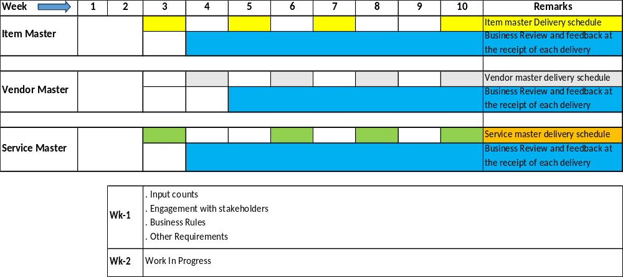

- Commercials:

SI No | Description | Input Count | Estimated Processed count | Per Unit | Price INR based on Est.Prc. Count | Remarks
1 | Item master | 47220 | 42000 | 50 | 21,00,000.00 | Any change in the counts to process will be charged on the prorate basis
2 | Vendor Master | 6349 | 6349 | 50 | 3,17,450.00 | Any change in the counts to process will be charged on the prorate basis
3 | Service Master | 28990 | 14000 | 50 | 7,00,000.00 | Any change in the counts to process will be charged on the prorate basis
All the attempted lines will be charged.
GST , all applicable taxes are extra to be added.

Payment Terms:
- Advance 20% against PO to be invoiced and paid immediately.
- At the end of first month-5th week additional 30% of project value will be invoiced to be paid within 30 days
- At the second month -9-10th week 30% of project value will be invoiced to be paid within 30 days.
- Remaining will be invoiced (no later than 12 weeks from PO date) post sign off to be paid with in 30days.

Point of Contact
- Grihasoft representative for this Contract is
  - Sudarshan B N , VP – Healthcare Services
    - Mobile : +91 99002 30226
    - Email: sudarshan@grihasoft.com

- Ujala Cygnus representative for this Project is :

    - Mobile :
    - Email:

For Ujala Cygnus

Name:

Designation:

Date:

Signature: __________________________________

For Grihasoft

Name: D.S. Madhuresha

Designation: CEO

Date:

Signature: _______________________________

